Frikadelli Racing looking forward to the team’s first appearance at the 24 Hours of Daytona

- Celebrated local heroes from the daunting Nürburgring Nordschleife take on the great American classic
- Frikadelli Racing one of the first outfits to race the new Porsche 911 GT3 R
- GTD racing car was being shipped to the U.S. on December 29
- Young Californian racer Connor de Phillippi joins team principal Klaus Abbelen, Patrick Huisman, Frank Stippler and Porsche junior Sven Müller at the wheel of the “world’s fastest meatball”

Barweiler (D) / Daytona (USA), January 4, 2016. Their home track is the legendary Nürburgring Nordschleife, one of the world’s most famous race tracks – now German team Frikadelli Racing faces another of motor racing’s greatest challenges: In January 2016, the team will be celebrating their international debut with their first appearance ever at the Rolex 24 at Daytona.

The outfit, founded by German entrepreneur Klaus Abbelen in 2005, is located in the Eifel village of Barweiler, just a few kilometers away from the entry to the daunting Nordschleife. Frikadelli Racing will be one of the first teams to race the brand-new Porsche 911 GT3 R. The sports car boasts more than 500 PS and is based on the Porsche 911’s model generation 991. The opening round of the IMSA WeatherTech SportsCar Championship 2016 will be the new GT3 R’s first outing.

Daytona Rookie Abbelen has gathered a fast and experienced driver line-up. He will share the Porsche’s cockpit with Californian Connor de Phillippi and German Porsche junior driver Sven Müller as well as “old” Porsche hands Patrick Huisman from the Netherlands and Frank Stippler from Germany. The latter both know the American classic by heart: Stippler – who has already won the 24 hour races at the Nürburgring and in Spa-Francorchamps – missed a class victory in Daytona 2013 only by 1.2 seconds. Huisman is also steeled by countless 24 hour races and is looking forward to his sixth race start on the 5.73 kilometer Daytona International Speedway in Florida.

“We are fully aware of the challenge that awaits us at Daytona” Abbelen states. “It has always been my dream to drive in this great race. We are very well prepared: The new Porsche 911 GT3 R looks very promising and with our strong driver line-up I see a good opportunity to fight at the front.”

Who the f**k is Frikadelli Racing?
Amongst the petrol heads that are following the popular endurance series VLN – which takes place exclusively on the Nürburgring – Frikadelli Racing has long gained cult status. One factor for this is undoubtedly “SpeedBee” Sabine Schmitz. The two-time winner of the Nürburgring 24 Hours is considered the queen of the Nordschleife. She literally grew up on the classic track and is said to have driven more than 20,000 laps there. The global TV audience knows Sabine from her quick-witted appearances in the celebrated British car magazine “Top Gear”. For years now she races “the world’s fastest meatball” (English for German specialty “Frikadelle”) around the “Ring”, mostly alongside Abbelen and Huisman. The reason for the car’s unique nick-name is its livery: the Porsche’s fenders feature the products of top sponsor Abbelen, who is a successful manufacturer of “Frikadellen” and other convenience food.

The distinctive livery of the 911 GT3 R, however, should not distract from the fact that Frikadelli Racing is a highly professional racing outfit. In 2010, Klaus Abbelen’s team moved to a state-of-the-art workshop with nearly 20,000 square feet floor space with an own engine test bench. Here, the team’s technicians prepare up to five racing cars at a time for their outings on the Nordschleife.

Frikadelli Racing is one of the first racing teams world-wide to be entrusted by Porsche with one of the newly developed 911 GT3 R. On December 29, 2015 the car – that is to race in the category GTD (for GT Daytona) as N°30 – was sent to the United States and has arrived on Thursday safely. Its first outing at Daytona’s tri-oval with its twisty infield and the famous banked curves will be at the “Roar” from January 8 to 10. The three testing days are the traditional kick-off for the racing season in the U.S.

Captions:

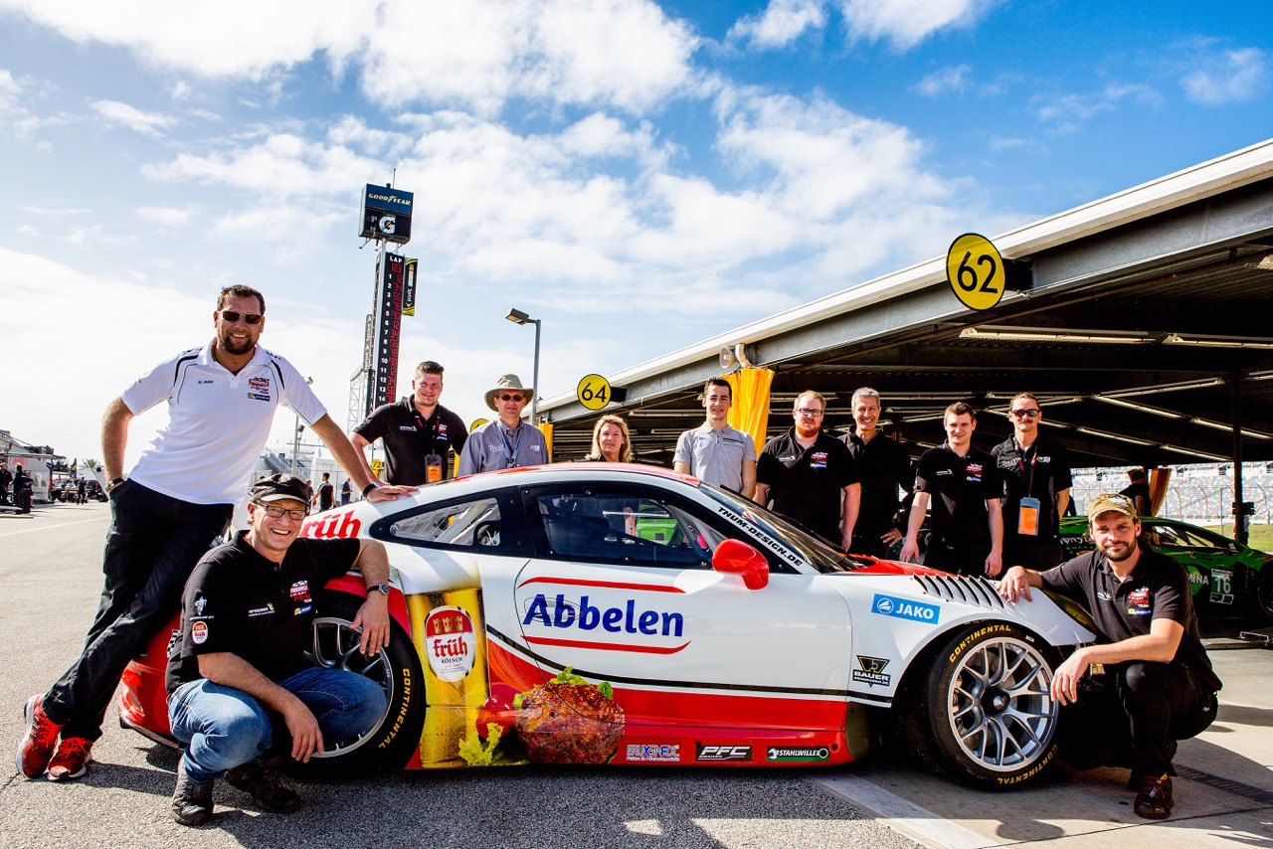

Arrival at Daytona: Frikadelli Racing and the new Porsche 911 GT3 R. On the left: team manager Erik Meyer, team owner Klaus Abbelen.

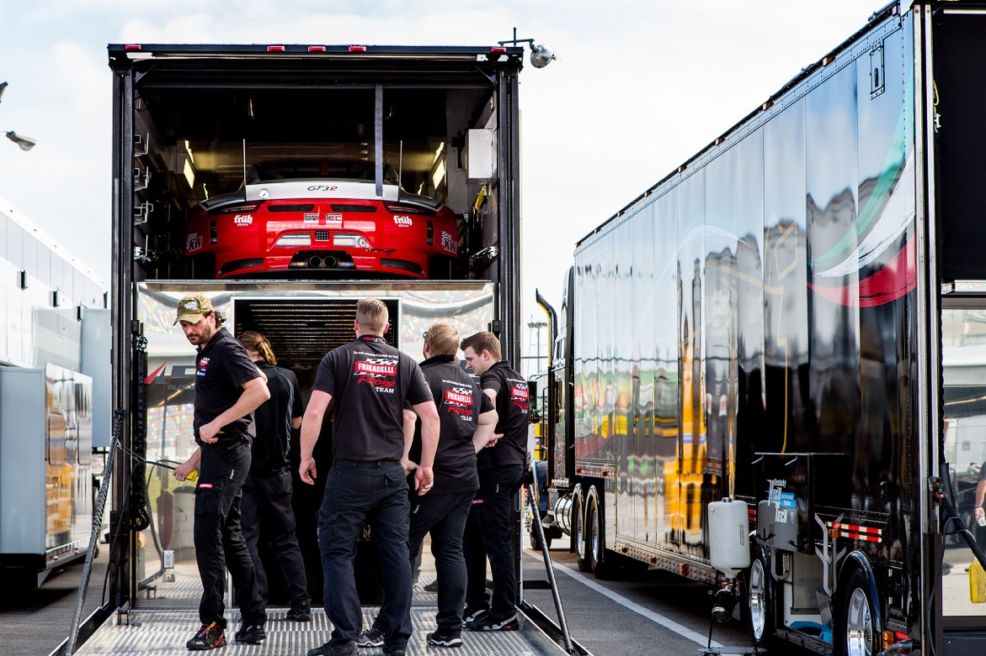

The Porsche 911 GT3 R of Team Frikadelli Racing being unloaded in Daytona.

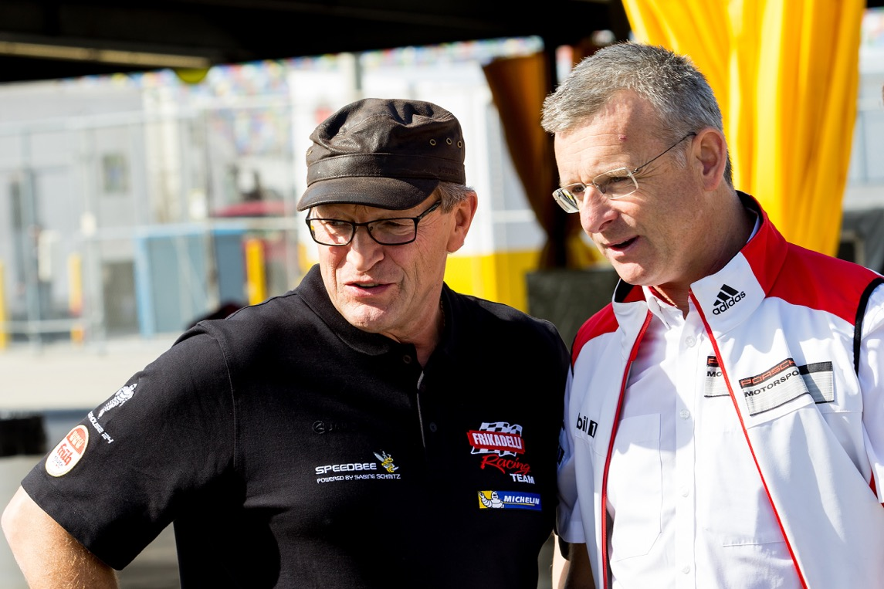

Ready for the team’s first experience of US racing: Frikadelli Racing team owner Klaus Abbelen (l.) together with Porsche Engineer Owen Hayes.

